FRENCH

Sample IPAs: Travel

IPA as a chapter or unit test
IPA as a comprehensive exam
or pre/post-assessment

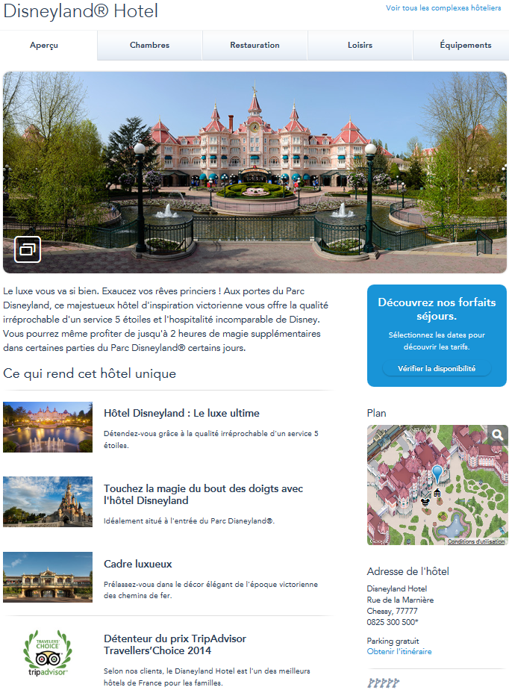

Clé:
navette gratuite service spa salle de sport
tennis piscine
service en chambre repas avec les personnages Disney

Hôtels Disney

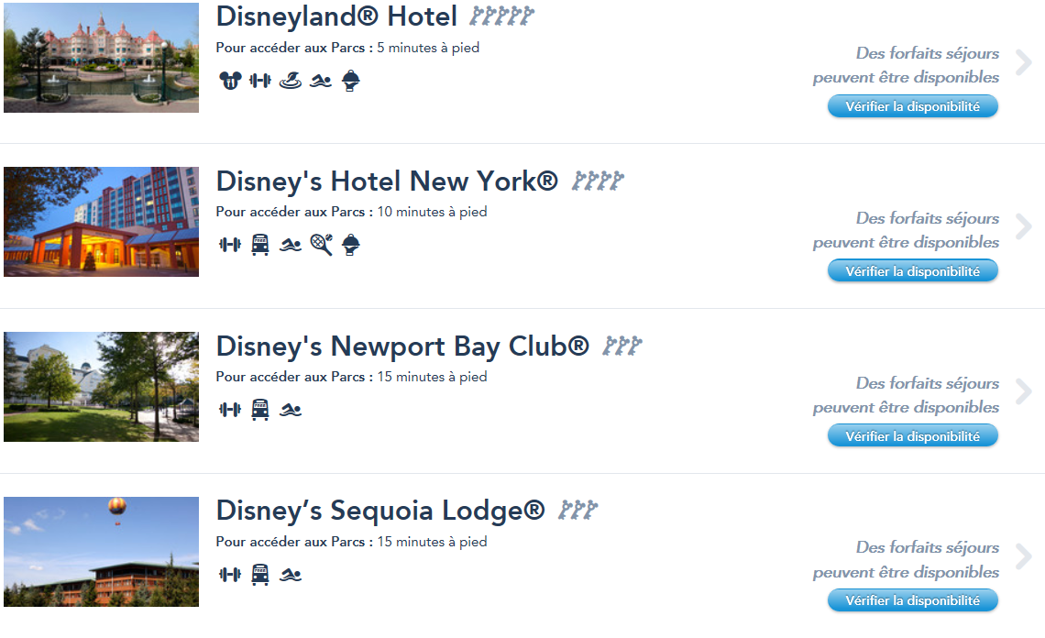

Français 1 - IPA for end of unit

Theme: Travel

DAY ONE: INTERPRETIVE

[Comprehension questions are based on the ACTFL template for Interpretive tasks and scored with the ACTFL rubric.]
A. Listening: https://www.youtube.com/watch?v=tCWoV_ZP_rY
[ Students watch a video of a little girl celebrating her 3rd birthday. She receives a birthday card from Mickey Mouse, telling her that she’ll be traveling to Disneyland Paris. ]
Comprehension Questions:
- Why is the family gathered together?
- Why is the little girl so excited by the card that her Mom reads to her?
- If the boy in the video received a similar card, what do you think it might say instead?
- Write at least three other details that you understood from this video.

B. Reading: http://www.disneylandparis.fr/hotels/disneyland-hotel/
http://www.disneylandparis.fr/hotels/
[ Students read hotel information printed from the Disneyland Paris website.]

1. KEY WORDS: Find 6 words that promote the high quality of Disney Hotels:
[Options: luxe, majestueux, 5 étoiles, unique, qualité, incomparable, élégant, meilleur]
2. MAIN IDEAS: Pick 3 hotels and give at least two specific reasons why you would want to
stay there:
3. CONTEXT: What do you think these phrases mean? The entire phrase is underlined in the
reading:
- 5 minutes à pied :
- Vérifier la disponibilité:
- la navette gratuite
(Continued on next page )
4. INFERENCES: Are these statements about Disneyland Paris true or false? Give information from the reading to justify your answer.
a) Overall, people are satisfied with the quality of the Disneyland Hotel.

b) A bonus to staying at Disney hotels is that you get extra time at the park.

c) Tourists can learn about French culture by staying at one of the Disney hotels.

DAY TWO (into Day Three, if needed): INTERPERSONAL

C. Conversation:
[Groups of three students. 5-6 minutes per group. Assessed with individual interpersonal
rubrics for each student.]
You want to plan a surprise trip to Disneyland Paris for (a family member) but other family members have different ideas of where the trip should be and why. Role play the scene with members of your family and decide on a final destination for the surprise trip.

DAY THREE (or Day Four) : PRESENTATIONAL

D. Writing: Choose one topic.
[Graded with Presentational Rubric]

a) You’re planning a surprise trip to Paris and Disneyland Paris for a friend or family member, so you need to pack his/her suitcase for the 10 day trip. Think about the activities you will be doing in Paris to help you plan what to pack. Write a list of at least 8 items you will pack for the trip and write the reason that you’re taking each item.

b) You’ve arrived in France for your trip to Disneyland Paris but the airline lost your luggage. The customs agent is a very suspicious man. He not only wants you to write down what was in your missing luggage, but he wants you to write why you packed each item, also. List at least 8 items that were in your luggage and why you packed that item.

Français 1 - Modifications to Unit IPA for Post-Assessment or Final Exam

Theme: Travel

* By the time of this assessment, students have done a unit on Paris and monuments,
La Défense, Versailles, Chartres, Giverny
INTERPRETIVE

A – B. Same video and reading activities as in Unit IPA.
C. Add an additional reading about a tourist attraction in Paris:
- Critique of Restaurant Jules Verne in the Eiffel Tower
http://www.tripadvisor.fr/Restaurant_Review-g187147-d719141-Reviews-Le_Jules_Verne-Paris_Ile_de_France.html
- Information from the “kids section” of the Notre Dame website
http://www.notredamedeparis.fr/spip.php?rubrique11
- Information about skate tours in Paris from the Paris Roller website.
http://pari-roller.com
INTERPERSONAL
Conversation: One-on-One with teacher.
[The teacher should guide the conversation to cover a variety of content covered in this course]
You are planning a surprise trip to Paris and the surrounding region with 3 different people (family member, friend, teacher, etc.). When are you going? Who is going? What do they need to pack and why? Where are you taking each person in Paris and why? What will you do/see/eat in Paris? How will you get around in Paris?
PRESENTATIONAL

Writing:
Your family is going to Paris for five days and they are relying on you to be their tour guide. When are you going? Who is going? Where are you staying? What are you packing and why?
Plan your itinerary for each day. What are you eating each day? Based on the season and weather, what are you wearing each day? What are you doing each day? Which tourist sites are you visiting each day? How will you get around Paris? What will you say in various situations?

