Español II or III – IPA for end of unit or end of year on Ecotourism

Theme: Travel, Environment

ECOTURISMO: Reading: http://blog.mexicodestinos.com/2015/02/25-increibles-paraisos-para-el-ecoturismo-en-mexico/
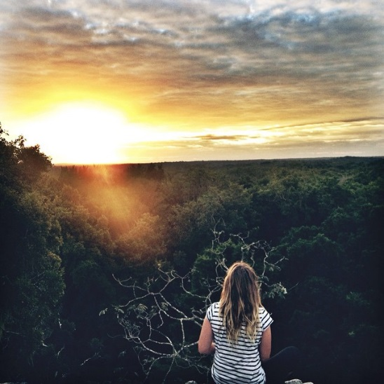

1. En una superficie de 331 mil hectáreas de selva se encuentra Calakmul. Una región llena de evidencias históricas de la convivencia entre el hombre y la naturaleza. Con más de 38 zonas arqueológicas y Bien Mixto Patriminio Mundial de la Humanidad por la UNESCO desde el 2014. Esta reserva natural es la principal de mesoamérica y la segunda más extensa de toda américa, hogar de miles de especies de animales y vegetales.

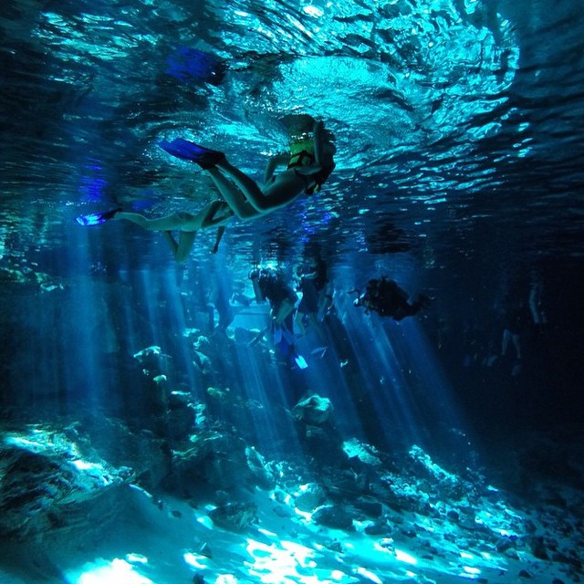

2. El buceo en cenotes es una de mejores actividades acuáticas que puedes llevar a cabo en la Riviera Maya. Y aunque hay decenas de lugares donde poder practicarlo, bucear en el Cenote Dos Ojos será una experiencia que te dejará sin palabras. Los efectos de luz bajo el agua y estar rodeado de cientos de estalacticas y estalagmitas te harán sentir literalmente en otro mundo. Se encuentra unos minutos antes de llegar a Tulum desde Playa del Carmen.

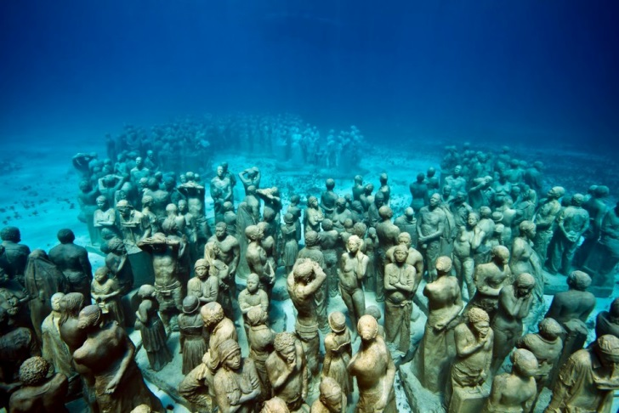

3. En el mar y frente a las hermosas playas de Cancún se encuentra un museo de arte contemporáneo. Fundado en el 2009, en el Museo Subacuático de Arte (MUSA) hay más de 500 esculturas que descansan para siempre en el fondo del mar. Cabe hacer mención que este museo bajo el mar se creo con la intención de mitigar el flujo de visitantes hacia los arrecifes naturales, y con ello disminuir el impacto de las actividades como el buceo o snorkel en esta área protegida.

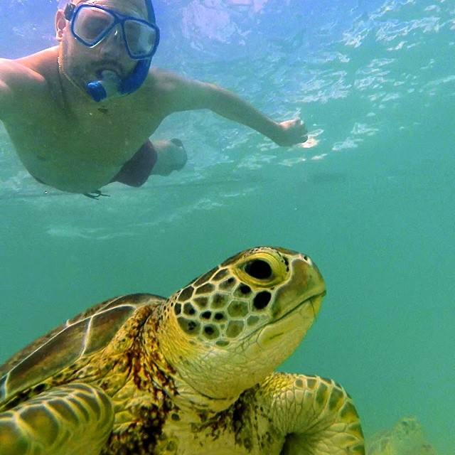

4. Akumal, en lengua maya, significa “Lugar de Tortugas”, es una de las playas más espectaculares de la Riviera Maya y además son santuario natural de las tortugas marinas, que han habitado el planeta desde hace más de 150 millones de años. Aprender a nadar con nuestras abuelas tortugas en su ambiente natural es una de las mejores experiencias que puedas tener en la vida. ¡Disfruta del Ecoturismo en México al estilo

DAY ONE: INTERPRETIVE

A. READING- Read about the following ecotourism sites near the Riviera Maya in Mexico. Then answer the following questions:
KEY WORDS: In these 4 articles find the Spanish words that best express the meaning of the following English words:
1. nature - ______________________________________
2. home - ___________________________________________
3. area, surface, space - _________________________________________
4. stalactites - ___________________________________
5. diminish - ______________________________________
6. tens - ____________________________________________
7. turtles - ________________________________
8. enjoy - __________________________________
9. jungle, forest - ________________________________________
10. archeological zone - ________________________________________

MAIN IDEAS:
1. #1 – What type of habitat is this?
__________________________________________________________________________
2. #2 – What type of ecotour is this?
________________________________________________________________________________________________________________________________________________________
3. #3 – What type of ecotour is this?
________________________________________________________________________________________________________________________________________________________
4. #4 – What would you see and do on this tour?

SUPPORTING DETAILS:
1. Circle the letter of each detail that is mentioned in the article (not all are included).
2. Write the letter of the detail next to where it appears in the text.

A. #1 – This area has many ancient Mayan sites.
_____________________________________________________________________

B. #1 – This is the largest UNESCO site in all of North America. ______________________________________________________________________

C. #2 – This is one of the only places that you can scuba on the Riviera Maya.
______________________________________________________________________

D. #2 – Here you scuba in an natural well that is similar to a cave.
______________________________________________________________________

E. #3 – This is a museum of contemporary art under the ocean.

F. #4 – Marine turtles are some of the oldest creatures on earth.
____________________________________________________________________________

B. LISTENING: https://www.youtube.com/watch?v=oCKywHaziB0 - Documentary on Mexico. Watch only a clip from 25:23 – 27:45.

Or Zaption version: http://www.zaption.com/tours/561e675dee553f244dd62ce5
(Students watch documentary on underwater museum in Cancun.)

KEY WORDS:
From the video, find these key words in Spanish. (Words are harder as we go down the list. Use as many words as your students’ level dictates.)

1. reefs - _____________________________________
2. sculptures - _____________________________________
3. the environment - _____________________________________
4. underwater - ______________________________________
5. coral - _____________________________________
6. hurricanes - _____________________________________
7. scuba diving – ___________________________________
8. anchored - _______________________________________
9. disastrous - ______________________________________
10. disperse - ________________________________________

MAIN IDEAS:

1. What is the ecological problem that they have in Cancun? What are they doing to solve this problem?

SUPPORTING DETAILS:
Circle the letter of each detail that is mentioned in the video. (Not all are mentioned.)

a. The statues can serve to help Cancun withstand the force of a hurricane.

b. Bottles and glassware should not be thrown into the ocean.

c. 80% of our coral reefs will be destroyed in the next ten years.

d. Coral reefs are important for the procreation of marine animals.

e. Jason Taylor has a passion for sculpting and for scuba diving.

f. Tourists are one of the main causes of the destruction of coral reefs.

g. Pieces of coral are implanted in the statues so that coral can grow.

h. Recycled concrete is used to make the statues.

INFERENCES:
1. Why would these underwater sculptures be an interesting place to scuba dive or snorkel?
Use evidence from the video.

________________________________________________________________________________________________________________________________________________________

2. Why are coral reefs important to Cancun? Use evidence from the video.

DAY TWO: INTERPERSONAL

C. Interpersonal:
In groups of 2 or 3 persons, discuss the following question:
1. If you could only choose do one of these tours, which tour would you choose? Why?

DAY THREE/FOUR: PRESENTATIONAL – Speaking and/or Writing

D. Presentational Speaking
1. You are on a service tour to Mexico. You form a volunteer group to pick up the trash from the side of the road and the beaches. Unite your creative impulses with your interest in preserving the environment and create a piece of art using the materials that you found that will urge tourists to respect the environment of Mexico. Explain to the class what your art represents, the materials used to create it, and where they were found.

E. Presentational Writing
2. Study these possible ecotourism venues in Mexico
http://blog.mexicodestinos.com/2015/02/25-increibles-paraisos-para-el-ecoturismo-en-mexico/
or document of 4 ecotours near the Riviera Maya.
Make a brochure in Spanish advertising an ecotour to this site.
Include:
- where you are going,
- what people will see and do there,
- the dates and times of the tours,
- what the participants need to wear,
- why this site is important to the environment

